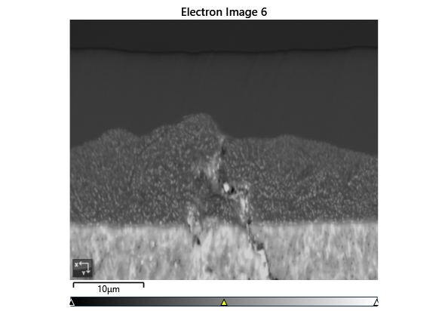

Settings

|  |  |
| --- | --- |
| Accelerating Voltage | 20.00 kV |
| Specimen Tilt (degrees) | 70.00 ° |
| Hit Rate | 72.93 % |
| Speed of Acquisition | 24.37 Hz |

Phases for Acquisition

|  |  |  |  |  |  |  |  |  |
| --- | --- | --- | --- | --- | --- | --- | --- | --- |
| Phase | a | b | c | Alpha | Beta | Gamma | Space Group | Database |
| Iron bcc (old) | 2.87 Å | 2.87 Å | 2.87 Å | 90.00 ° | 90.00 ° | 90.00 ° | 229 | HKL |
| Iron fcc | 3.66 Å | 3.66 Å | 3.66 Å | 90.00 ° | 90.00 ° | 90.00 ° | 225 | HKL |
| Nickel | 3.52 Å | 3.52 Å | 3.52 Å | 90.00 ° | 90.00 ° | 90.00 ° | 225 | OINA Phases |
| Pyrite | 5.42 Å | 5.42 Å | 5.42 Å | 90.00 ° | 90.00 ° | 90.00 ° | 205 | OINA Phases |

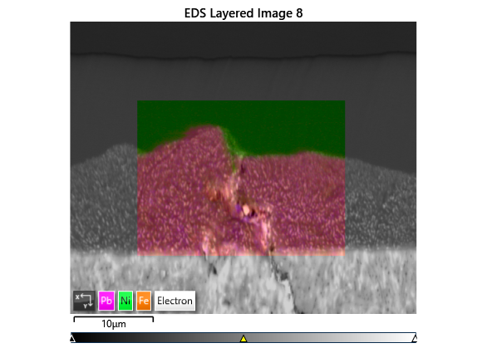

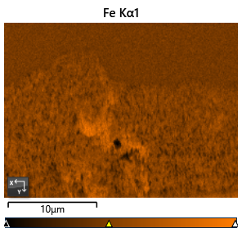

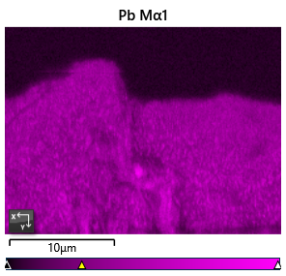

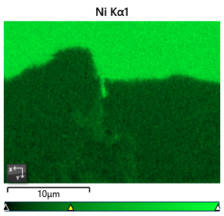

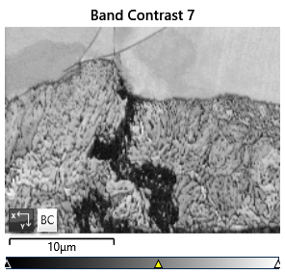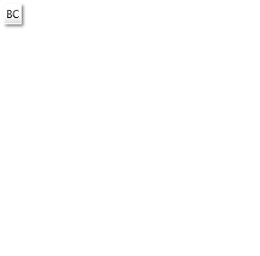

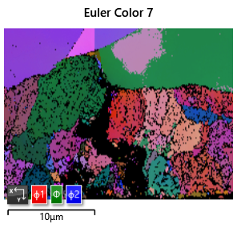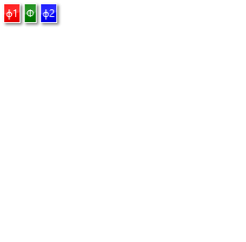

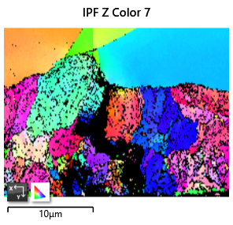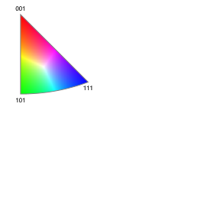

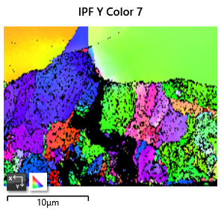

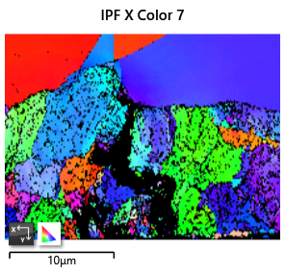

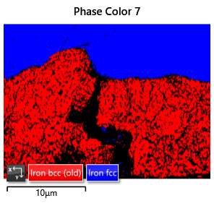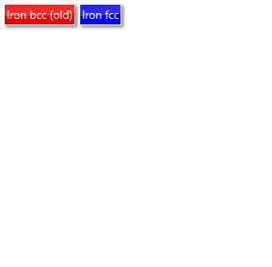

Phase Fraction

|  |  |  |  |  |  |  |  |  |  |  |
| --- | --- | --- | --- | --- | --- | --- | --- | --- | --- | --- |
| Phase Name | Phase Fraction (%) | Phase Count | Mean Band Contrast | Standard Deviation Band Contrast | Min Band Contrast | Max Band Contrast | Mean MAD | Standard Deviation MAD | Min MAD | Max MAD |
| Iron bcc (old) | 43.16 | 15667 | 87.92 | 13.25 | 17.00 | 128.00 | 0.87 | 0.27 | 0.24 | 2.00 |
| Iron fcc | 29.77 | 10806 | 100.33 | 7.18 | 33.00 | 115.00 | 0.65 | 0.16 | 0.18 | 1.99 |
| Nickel | 0.00 | 0 | 0.00 | 0.00 | 0.00 | 0.00 | 0.00 | 0.00 | 0.00 | 0.00 |
| Zero Solutions | 27.07 | 9827 | 55.84 | 22.79 | 0.00 | 117.00 |  |  |  |  |